**Experiment 2.1**

**Student Name: Yana Srivastava UID: 20BCS2279**

**Branch: BE CSE Section/Group: 20BCSWM_906 B**

**Semester: 5th Date of Performance: 29.09.2022**

**Subject Name: Problem Based Learning in Java Subject Code: 20CSP_321**

1. **Aim/Overview of the practical:**

Collect and Group Cards.

1. **Task to be done/ Which logistics used:**

Write a program to collect and store all the cards to assist the users in finding all the cards in a given symbol.

This card games consist of N number of cards. Get N number of cards details from the user and store the values in Card object with the attributes symbol and number.

Store all the cards in a map with symbol as its key and list of cards as its value. Map is used here to easily group all the cards based on their symbol.

Once all the details are captured print all the distinct symbols in alphabetical order from the map. For each symbol print all the card details, number of cards and their sum respectively.

1. **Steps for experiment/practical/Code:**

import java.util.*;

public class card{

public static void main(String[] args)

{

Scanner input = new Scanner(System.in);

List<Integer> valueList = new ArrayList<Integer>();

TreeMap<String,List<Integer>> mapObj = new TreeMap<String,List<Integer>>();

int total,index,value,sum = 0,count = 0;

System .out.println("Enter Number of Cards");

total = input.nextInt();

String symbol;

for(index = 1; index <= total;index++)

{

System.out.println("Enter Card" + " " +index);

symbol = input.next();

value = input.nextInt();

if(mapObj.containsKey(symbol))

{

valueList = mapObj.get(symbol);

valueList.add(value);

}

else

{

valueList = new ArrayList<Integer>();

valueList.add(value);

mapObj.put(symbol,valueList);

}

}

System.out.println("Distinct Symbols are:");

for(Map.Entry getData : mapObj.entrySet())

{

System.out.println(getData.getKey() + " ");

}

System.out.println();

for(Map.Entry getData : mapObj.entrySet())

{

System.out.println("Cards In " + getData.getKey() + " Symbol :");

ArrayList<Integer> temp = (ArrayList<Integer>) getData.getValue();

Iterator itr= temp.iterator();

while(itr.hasNext())

{

count++;

int val = (int) itr.next();

System.out.print(getData.getKey());

System.out.println(" " + val);

sum += val;

}

System.out.println("Number Of Cards : " + count);

System.out.println("Sum Of Numbers : " + sum);

sum = 0;

}

input.close();

}

}

1. **Result/Output/Writing Summary:**

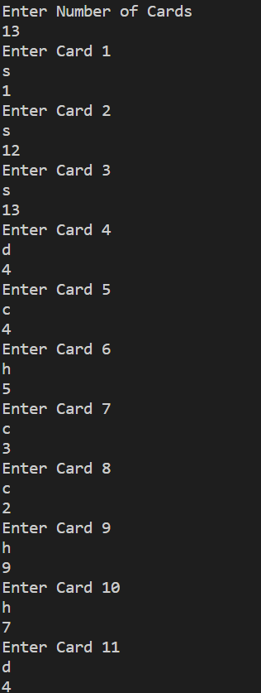

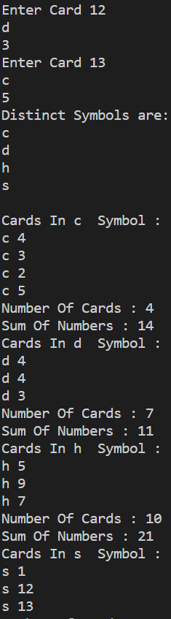



**Learning outcomes (What I have learnt):**

* 1. Learnt about maps.
  2. Got an overview of the maps and hashing.
  3. Get to know about crucial test cases.
  4. Got an understanding about referencing of maps.

**Evaluation Grid (To be created as per the SOP and Assessment guidelines by the faculty):**

|  |  |  |  |
| --- | --- | --- | --- |
| Sr. No. | Parameters | Marks Obtained | Maximum Marks |
| 1. |  |  |  |
| 2. |  |  |  |
| 3. |  |  |  |
|  |  |  |  |